Reverend Veronica Don 603-878-1684 www.masoncongregatioalchurch.org

Our live Zoom is easy! You can simply click on the blue link we send out, and a window will open that you say yes, “launch Zoom,” and you are in. If it is your first time on Zoom, it will ask you to download Zoom onto your device then it will give you the launch window.
When you enter zoom, the host will let you in from the ‘waiting room’ and you will be muted when you enter. Simply hover your cursor arrow over the bottom (or sometimes it’s on the top) of your screen, over the little picture of the microphone. If it has a red line, you are muted. Click on it, and you are unmuted! You can stay unmuted until the service begins, then as usual we are all silent, so you will be muted by the host until the service is over.
Join Zoom Meeting. Click on the link below, or copy and paste the link into your search engine.
https://us02web.zoom.us/j/82121212979 Any questions, please call Michelle at 603 801-9140 for help! Hope to see you on Sundays.

Richard Rohr's Daily Meditation From the Center for Action and Contemplation cac.org.
Practice: A Commitment to Nonviolence
My longtime friend, Catholic priest and peace activist John Dear, has dedicated his life to the practices and teaching of nonviolence. His work with the Fellowship of Reconciliation and other organizations is truly an example of contemplation expressing itself in action for peace and justice. He has now founded “The Beatitudes Center for the Nonviolent Jesus.” Our executive director, Michael Poffenberger, and I recently visited John at his new home in California, and received much gracious hospitality and kindness.
The Fellowship of Reconciliation [FOR] has worked to bring together people on all sides in all the conflicts of the world, in pursuit of peace and reconciliation. . . . FOR started a wide variety of campaigns—sending delegations around the world . . . teaching people creative alternatives of nonviolence. . . . In the 1940s, FOR helped form the Congress of Racial Equality and set up “Journeys of Reconciliation,” which promoted integration in the segregated South. . . . [Today,] after nearly a century of dedicated peacemaking, members of the Fellowship of Reconciliation remain as committed as ever to the mission of promoting peace, justice, and nonviolent action. . . .
FOR is learning the great wisdom of the ages: that making peace requires persistent reconciliation. Peace does not happen overnight. There is no immediate result. It is a lifelong struggle and requires a lifetime commitment. It necessitates patience and dedication, even facing the worst odds. The challenge of reconciliation is to keep at it—to keep opponents talking, to encourage compassionate listening, to invite forgiveness, to compromise for the sake of peace, and to never give up the dream.
When FOR moved from being exclusively Christian to truly interfaith in the late 1950s, it broadened its mission to include building bridges between all the world’s religions for the sake of peace. Today, FOR embraces Christians, Jews, Muslims, Buddhists, Hindus, other people of faith, and those with no formal religious affiliation. Through this interfaith commitment to nonviolence, we are forging a modest, new path into a new future for us all.
In contemplation, we empty ourselves of our own hurts, agendas, and even some of our most treasured beliefs. It is a practice of inner nonviolence, which gives us confidence to join with others to create a more peaceful world. John Dear continues:
The work of peace and reconciliation is not only political, it’s human work, and it’s spiritual. The God of peace is determined to reconcile the human race, and employs whomever will help in this great project. . . . As we have seen from the abolitionist, suffragist, civil rights, antiwar, human rights, and environmental movements, patient grassroots organizing and reconciliation over time has the power to transform nations and the world.
True contemplation always leads to action on behalf of a world in desperate need of healers and peacemakers, channels of God’s grace by any name. How might you join in that work in the year ahead?
John Dear, Living Peace: A Spirituality of Action and Contemplation (Doubleday: 2001), 207–208, 210–213.
Upcoming Events

- Damon Stroms Stefani would like Damon to be baptized at Mason Church in the next few weeks. The pastor and deacons will work to make this happen! Damon is thriving, gaining weight beautifully on nothing but moma milk. Stefani has another month at home with him. She can be reached at 509 Old County Rd, Mason, NH 03048
- Mason Church Annual Meeting in February 2021 No doubt it will be the 1st ever Zoom annual meeting! So just a reminder: Deacons, Treasurer, and all other committees, your annual reports are due in mid-January. Send these to Dotsie: dotsiemill@gmail.com Judy Wilkins, chair of the Nominating Committee is asking for people to step up for the following openings: Nominating Committee, Stewardship, Church Gifts, Historian, and Crathern Room Curator. You can reach Judy at robertwilkins86@comcast.net or call her at 878-3218

- Community Supper – Dee just rounded us up in an email update, and the consensus was we will all stay home, and will reassess the situation in the spring, at a tailgate meeting in the parking lot. The faithful cooks, cleaners, and bottle washers are lurking in the eves, just waiting to get back to work! In the meantime, they stay in touch and look out for each other as well, due to the outreach/caring of Dee Mitchell and Barbara Devore! Thank you, Team CS.

- Nashua Soup Kitchen - In this New Year, Share your love and energy in this outreach mission of our community. They were so appreciative of the food/household items we sent for their Christmas baskets, especially the $10 gift certificates for Market Basket groceries. Contact Kathy Chapman, chapman.kathygmail.com or 878-4993 if you need information. You can check their website to see what’s going on, and what the needs are: www.nsks.org 603 889-7770 You can donate online!

- St Vincent DePaul Food Pantry Call 878-0518 or direct to Maureen 291-0022 This is our local food pantry that can always use your support. We still have our tote in the church for items. Occasionally there are items left there, and either Bettie or I will take them to St. Vincent DePaul

- Winter Coats Collection by Lions Club Thank you to all who donated coats. The Donation box is gone, but they will collect again next year, so please do not leave off any more coats for now!
- Introducing Hope for 2021!
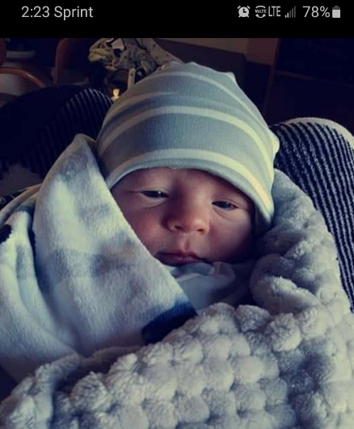
- On your left: Introducing Carson Hayworth, Reverend Veronica’s great grandson! Born a few weeks early, and doing very well.

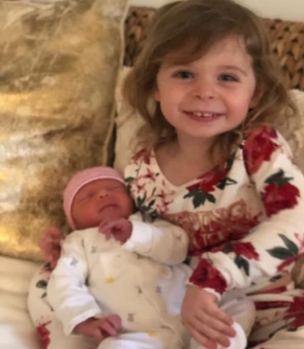
- Below: Proud grammy Edie Rowse says: Hugo Thomas Fallon was born December 19, has a three-year-old big sister Kaia Nicolette (middle name chosen by my husband Tom before she was born). Parents are Tom and Cassie Fallon...Tom is the grandson of James and Anna Rowse of Hilltop Farm in Mason and now living in Summit, NJ

- And baby boy Damon, in the gray stripes, is Stafani Stroms darling boy, born 12/2.
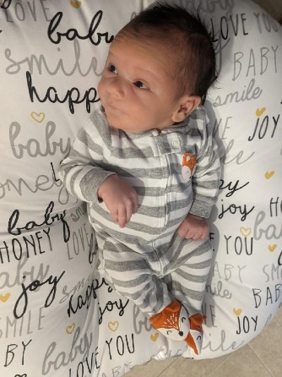

- Local News: There is a website, www.masonnhenergy.org that you can access for how to save energy in your home by tapping into Ever Source’s energy savings ideas, by find out how to solarize your house thru a “barn raising” kind of idea that will save you about 30% of the costs of adding solar. Check out the videos of Mason solar arrays. The 26% return on your investment by the Federal Government, makes your investment in the future a real savings now. The more solar arrays NH has, the more stable the energy grid! Now that’s the sustainability that God’s earth deserves.

- More local news: Mason Conservation Commission has trails for you to explore! Try the newly trimmed up Bronson Potter Trails off Greenville Rd, or the Florence Roberts Trail off Valley Road. Go to the Town website, and find more info under the Conservation Commission tab. This is a way to refresh your soul in nature, and to energize your body.
Remember our church family in your prayers, a call, or a card. Loneliness can be relieved by caring and connection, at least temporarily, and price of this “gift” is mostly free!

- Jean Randle is healing from her broken hip. She is now at home with her daughter in MA. On Dec 28th she was hospitalized for a week due to a stroke. Send hope and love cards to: 192 Millbrook Drive, East Long Meadow, MA 01028 or call her at (413) 575-9838 or contact her daughter, Ellen Randle (413) 531-6864

- Harry Spears Remember Harry as it takes months to heal from the heart surgery he had in the fall. You can send cards to his home. 966 Starch Mill Rd, Mason, NH 03048. Or give him a call at 400-9209 Harry has been a friend of Mason Church for many years, and participated in worship this summer under the Maple Tree. A special time for all!

- Steve Tamulonis Steve moved up North to help out with aging family, and we will miss him A LOT. He has been the Mason Musician for over 20 years. If there was music happening somewhere, you were likely to see Steve there. He participated in our choir, our Coffee House, our Praise Band, and organized other musical events in Mason. The youth group benefitted by his leadership and support as well. And the Town of Mason has looked tidy and trimmed due to his mowing, trimming, painting, and repairs. His neighbors benefitted by his thoughtful help in dozens and dozens of ways. He will always be welcome here! His new address is: Steve and Jeanne 24 River Street, Ashland NH 03217

- Prayer Shawl Ministry Speaking of Susan who has been the backbone of the Prayer Shawl Ministry, we are in need of prayer shawls. We continue to have calls from friends of friends, or relatives of friends who want a special shawl. We can mail these out, but it should be done thru a request to Rev Veronica or a Deacon. We sew on a 3 inch crocheted cross, if you would like, and adapt the Prayer Shawl poem with the person’s name, and name of family members if indicated. Knitters needed! I can provide yarn and pattern for any knitters. Contact Michelle 878-1680 or miscott39@gmail.com.

- Susan and Jim Suokko have moved permanently to Florida now. Their Florida address is: 8814 28th Ave. Palmetto, FL 34221. They are a permanent part of our church family, and so keep in touch with them!.

- Laila Washburn at 101 years old, is another beloved member of our church community. Laila lives at Summer Hill Assisted Living in Peterborough. She loves company and cards, so you can imagine how hard Covid is to understand!. Send cards to: Summer Hill, 183 Old Dublin Rd, Peterborough, NH 03458. Call ahead if you have anything to drop off to her. 924-6238

- Gretchen and Wally Brown Always in need of a little cheer, Gretchen needs contact with the outside world, so stop by with a wave through the window, bring a meal, or just to pick up syrup and say hello!
Cards to: 421 Meetinghouse Hill Rd, Mason, NH 03048 phone: 878-1481

- Our Coffee House friend, Jon Pearson was very ill due to cancer since last year, and died in December. He supported the coffee house, wrote wonderful songs, and also came to our Halloween Trunk and Treat events in full costume. In addition, he was known for his kind, gentle manner, and keen humor. His partner, Pat Greene, who called Jon her ‘rockstar’ is missing him profoundly. Her address is: 1275 Valley Rd, Mason, NH 03048

- Police Chief Kevin Maxwell is back to work! Our prayers for continued good health.

Need a ride? Please spread the word about CVTC. It’s free to riders, and the drivers can be reimbursed for gas! A win-win all around. It’s so simple to pick up a trip, give the ride, (make a new friend or two), and the CVTC administration is efficient and kind. Really kind!
Due to Covid and the average age of the drivers, they are in need of drivers to serve the community.

